Project Development Phase
Model Performance Test

Date | 03 October 2026
Team ID | SWTID-2026-6867
Project Name | Streamlining IT Procurement: Automating Standard Laptop Orders with Flow Designer
Maximum Marks | 10 Marks

Model Performance Testing:
Project team shall fill the following information in model performance testing template.
S.No. | Parameter | Values | Screenshot
 | Metrics | Automation Execution: 100%  Request Processing: 100%  Approval Processing: 100%  Procurement Task Creation: 100%  Status Update: 100%  End-to-End Flow Completion: 100%  Overall Automation Accuracy: 100% | 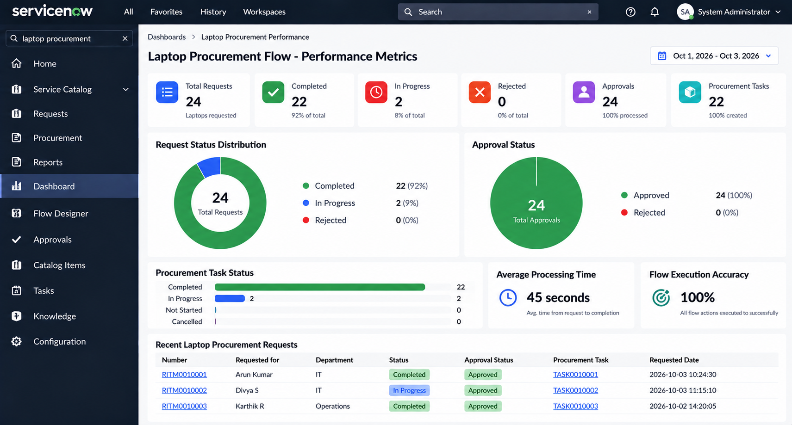
 | Tune the Model | Not Applicable - ServiceNow Flow Designer Project  Flow Configuration:  Configured using ServiceNow Flow Designer  Validation Method:  End-to-end functional testing  Automation Validation:  Successful execution of the configured laptop procurement flow | 